|  |  |  |
| --- | --- | --- |
| **CAN THO UNIVERSITY**  **COLLEGE OF INFORAMTION AND COMMUNICATION TECHNOLOGY**  **🙞 🕮 🙜**    **PROJECT – FUNDAMENTAL TOPICS**  **INFORAMATION TECHNOLOGY**  **(HIGH-QUALITY PROGRAM)**    **BUILDING A WEBSITE FOR SEARCH AND HOTEL BOOKING USING SPRINGBOOT & REACTJS**     |  |  | | --- | --- | | **Advisor:**  TS. Lâm Nhựt Khang | **Student:**  Nguyễn Gia Linh  Student ID: B2111934  Class: 2021-2025 ( Cohort K47) |   Cần Thơ 11/2024 |

**INSTRUCTOR’S COMMENTS**

🙜-----🕮-----🙞

|  |  |
| --- | --- |
|  | Cần Thơ, ngày …. tháng … năm 2024  **Advisor**  **Lâm Nhựt Khang** |

**THANK YOU!**

I would like to extend my heartfelt gratitude to Ms. Lam Nhut Khang, whose guidance and support greatly influenced my implementation process. Her valuable advice and dedication provided me with the encouragement I needed to overcome many challenges along the way.

Additionally, I would like to express my sincere thanks to the faculty of the School of Information and Communications Technology for imparting foundational knowledge that enabled me to complete my thesis. Their unwavering support, guidance, and commitment have been instrumental throughout my academic journey.

I am also deeply grateful to Can Tho University, which has been not only a place of learning but also a community for my personal and professional growth. I am proud to be a student of this institution and will carry the values and skills I have acquired here throughout my life and career.

I wish Ms. Khang continued health, happiness, and success in her teaching career.

Thank you sincerely,

Nguyễn Gia Linh

**TABLE OF CONTENT**

A. INTRODUCTION 11

**1.** **Problem statement:** 11

**2.** **Research objectives:** 11

**3.** **Subjects and scope of research:** 12

**3.1.** **Research subjects** 12

**3.2.** **Research scope** 12

**4.** **Research Methodology:** 13

**5.** **Research content:** 13

**6.** **Layout:** 13

B. CONTENT 15

**CHAPTER 1.** **REQUIREMENT DESCRIPTION** 15

**1.1.** **Related theoretical basis:** 15

**1.1.1.** **ReactJS** 15

**1.1.2.** **Redux** 15

**1.1.3.** **Tailwind CSS** 16

**1.1.4.** **Database MySQL** 16

**1.1.5.** **Client – Server** 16

**1.1.6.** **SpringBoot framework** 17

**1.2.** **Description system:** 17

**1.3.** **Require function:** 18

**1.3.1.** **User management** 18

**1.3.2.** **Administrator Functions** 18

**1.3.3.** **Hotel Owner Functions** 18

**1.3.4.** **Customer Functions** 18

**CHAPTER 2.** **SOLUTION DESIGN** 19

**2.1.** **Overall architecture:** 19

**2.2.** **Conceptual data model ( CDM)** 20

**2.3.** **Flowchart diagram of the system:** 21

**2.4.** **System functions:** 22

**2.4.1.** **Functions for customers** 22

**2.4.2.** **Functions for hotel owners** 23

**2.4.3.** **Functions for administrators** 24

**2.5.** **Database** 25

**2.5.1.** **Hotels** 25

**2.5.2.** **Customers** 25

**2.5.3.** **Rooms** 26

**2.5.4.** **Reviews** 26

**2.5.5.** **Bookings** 26

**2.5.6.** **Accounts** 27

**CHAPTER 3.** **SOLUTION IMPLEMENTATION** 28

**3.1.** **Interface** 28

**3.1.1.** **Home** 28

**3.1.2.** **Hotel** 30

**3.1.3.** **Service** 31

**3.1.4.** **Review** 32

**3.1.5.** **Contact** 33

**3.1.6.** **Booking** 34

**3.1.7.** **Favorite** 35

***3.1.8.*** **Profile** 36

**3.1.9.** **Log-in** 37

**3.1.10.** **Register** 38

**3.1.11.** **Admin Hotel** 38

**3.1.12.** **Admin Room** 40

**3.1.13.** **Admin Booking** 42

**3.1.14.** **Admin User** 44

**3.2.** **Design Description using operating system and hardware** 46

**3.2.1.** **Operating environment** 46

**3.2.2.** **Requires external communication** 46

**CHAPTER 4.** **TESTING AND EVALUATION** 48

**4.1.** **Testing objectives:** 48

**4.2.** **Testing scenarios:** 48

**4.2.1.** **Register function** 48

**4.2.2.** **Login function** 49

**4.2.3.** **Update profile function** 49

**4.2.4.** **Logout function** 49

**4.2.5.** **Create Admin User function** 49

**4.2.6.** **Create Admin Booking function** 50

**4.2.7.** **Create Admin Hotel & Room function** 50

**4.2.8.** **Create Add to Favorite function** 50

**4.2.9.** **Create Booking function** 50

**4.2.10.** **Create Payment function** 51

**4.2.11.** **Create Filter Hotel function** 51

**4.3.** **Testing results:** 51

**4.3.1.** **Register function** 51

**4.3.2.** **Login function** 51

**4.3.3.** **Update profile function** 52

**4.3.4.** **Logout function** 52

**4.3.5.** **Admin User function** 52

**4.3.6.** **Admin Booking function** 52

**4.3.7.** **Admin Hotel & Room function** 52

**4.3.8.** **Add to Favorite function** 53

**4.3.9.** **Booking function** 53

**4.3.10.** **Payment function** 53

4.3.11. **Filter Hotel function** 53

C. CONCLUSION 54

**1.** **Achieved results :** 54

**2.** **Future directions:** 54

TÀI LIỆU THAM KHẢO 55

PHỤ LỤC 56

**Image category**

Figure 1: Over Architecture 19

Figure 2 CDM 20

Figure 3 Flowchart 21

Figure 4: Customer function 22

Figure 5: Hotel Owner function 23

Figure 6: Admin funciton 24

Figure 7: view Home / header 28

Figure 8: view Home / Welcome 28

Figure 9: view Home / Discount 29

Figure 10: view Home / Popular Hotel 29

Figure 11: view Home / Footer 29

Figure 12: view Hotel 30

Figure 13: view Hotel / Discount 30

Figure 14: view Hotel / Filter & List Hotel 30

Figure 15: view Hotel / Footer 31

Figure 16: view Service / Header 31

Figure 17: view Service 31

Figure 18: view Service / Footer 32

Figure 19: view Review / Header 32

Figure 20: view Review 32

Figure 21: view Review / Footer 33

Figure 22: view Contact / Header 33

Figure 23: view Contact 33

Figure 24: view Contact / Footer 34

Figure 25: view Booking / Header 34

Figure 26: view Booking 34

Figure 27: view Booking 35

Figure 28: view Booking / Footer 35

Figure 29: view Favorite / Header 35

Figure 30: view Favorite 36

Figure 31: view Favorite / Footer 36

Figure 32: view Profile / Header 36

Figure 33: view Profile 37

Figure 34:view Profile / edit Profile 37

Figure 35: view Profile / Footer 37

Figure 36: view LogIn 38

Figure 37: view Register 38

Figure 38: view Admin DashBoard 39

Figure 39: view Admin Hotel 39

Figure 40: view Admin Hotel / add Hotel 40

Figure 41: view Admin Hotel / edit Hotel 40

Figure 42: view Admin Hotel / delete Hotel 40

Figure 43: view Admin Room 41

Figure 44: view Admin Room / add Room 41

Figure 45: view Admin Room / edit Room 42

Figure 46: view Admin Room / delete Room 42

Figure 47: view Admin Booking 43

Figure 48: view Admin Booking / add Booking 43

Figure 49: view Admin Booking / edit Booking 44

Figure 50: view Admin Booking / delete Booking 44

Figure 51: view Admin User 44

Figure 52: view Admin User / add User 45

Figure 53: view Admin User / edit User 45

Figure 54: view Admin User / delete User 46

**Table category**

Table 1 Database hotels 25

Table 2 Database customers 25

Table 3 Database rooms 26

Table 4 Database reviews 26

Table 5 Database bookings 26

Table 6 Database accounts 27

Table 7 Register funcion 48

Table 8: Login function 49

Table 9: Update profile function 49

Table 10: Logout function 49

Table 11 Create hotel function 49

Table 12: Edit hotel function 50

Table 13 : Delete hotel function 50

Table 14 : Create Add to Favorite 50

Table 15: Create Booking 50

Table 16: Payment 51

Table 17: Filter 51

Table 18: Testing register function 51

Table 19: Testing login function 51

Table 20: Testing update profile function 52

Table 21: Testing logout function 52

Table 22: Testing create hotel function 52

Table 23: Testing edit hotel function 52

Table 24: Testing delete hotel function 52

Table 25: Add to Favorite 53

Table 26: Booking 53

Table 27: Payment 53

Table 28: Filter Hotel 53

**ABSTRACT**

In the era of Technology 4.0, the Internet has become an essential tool for managing and sharing information, whether on a national level or within local communities. As Internet usage expands, tourists’ expectations continue to rise. Many travelers face challenges in finding suitable hotels before they arrive or experience dissatisfaction when accommodations fail to meet expectations, leading to frustration and wasted time.

To address these needs, our project, titled **"Building a Hotel Search and Booking Website Using Spring Boot & ReactJS"** aims to provide a convenient solution. This platform enables tourists to find and reserve accommodations in advance, offering a seamless experience. With just a few steps on their device, users can easily locate a comfortable place to stay that perfectly matches their preferences, ensuring a more satisfying travel experience

1. INTRODUCTION
2. **Problem statement:**

* Vietnam boasts a thriving tourism industry, with rising numbers of both domestic and international tourists. This growth drives an increasing demand for efficient hotel search and booking solutions.
* While numerous hotel search and booking websites exist, many fall short of fully meeting user needs. Some platforms lack user-friendly interfaces, are challenging to navigate, or provide insufficient hotel information.
* In response to these issues, the "Hotel Search and Booking Website" project was developed to offer users a fresh perspective on local accommodations. This platform not only aims to make finding and booking hotels easier but also brings a unique, vibrant experience to users' lives. Additionally, the website serves as a tool to promote local culture and attractions to a broader audience.

1. **Research objectives:**

* The Hotel Search and Booking Website using Spring Boot is designed to comprehensively meet the needs of both users and hotel providers. Key features include:
* User-Friendly Interface: The website will offer an attractive, intuitive interface that is easy to navigate, enabling users to effortlessly search for and book hotel rooms.
* Comprehensive Hotel Information: Detailed information on each hotel, including addresses, photos, prices, and available amenities, will be provided to ensure users can make informed choices.
* Simple Booking Process: A streamlined, straightforward booking process will allow users to complete reservations easily and efficiently.
* This website aims to enhance the user experience while addressing the needs of the hospitality industry.

1. **Subjects and scope of research:**

To address the issues identified, this project will focus on researching the following topics:

* **Theoretical Research:**
* ReactJS: Understand how to use ReactJS for building the system's user interface
* Supporting Libraries and APIs for ReactJS: Explore libraries and APIs that integrate with ReactJS to enhance functionality.
* Spring Boot Framework: Study the Spring Boot framework for back-end development and integration.
* **Technical Research:**
* Database Design: Develop a database schema for effective data storage and retrieval.
* Framework and Library Utilization: Utilize frameworks and libraries to streamline development.
  1. **Research subjects**
* **Users:** Focus on website users who search for and book hotels, including groups such as tourists and business travelers,...
* **Hotel:** Investigate hotels that register on the website to enable room searching and booking.
  1. **Research scope**
* **User Needs Analysis:** Investigate user requirements for a hotel search and booking website, considering interface design, features, pricing, and more
* **Competitive Analysis:** Study existing hotel search and booking websites to identify their strengths and weaknesses and apply best practices.

1. **Research Methodology:**

- **Literature Review:** Conduct research through existing documents and literature.

- **Field Survey:** Perform surveys with real users and stakeholders.

- **Data Analysis:** Analyze collected data for insights and trends.

1. **Research content:**

- **User Needs Analysis**: Analyze user requirements by examining existing websites. Follow a structured process of design, development, testing, deployment, and maintenance for the website.

- **Technology Stack**:

* Back-end: Spring Boot Framework
* Front-end: ReactJS
* Databse: MySQL

- **Development Tools**:

* Tool design data: My SQL Workbench 8.0 CE
* Tool installer: VSCode
* Implementation support tools: Web Browser

1. **Layout:**

The contents of the thesis include:

* A. Introduction:
* Problem statement
* Research objectives
* Object and scope of the study
* Research Methods
* Research content
* Layout
* B. Content:
* Chapter 1: REQUIREMENTS DESCRIPTION
* Chapter 2: SOLUTION DESIGN
* Chapter 3: SOLUTION IMPLEMENTATION
* Chapter 4: TESTING AND EVALUATION
* C. Conclusion:
* Result
* Develop

1. CONTENT
2. **REQUIREMENT DESCRIPTION**
   1. **Related theoretical basis:**
      1. **ReactJS**

* ReactJS is an open source JavaScript library, developed by Facebook, used to build user interfaces (UI) for web applications. React's main goal is to help develop fast, efficient, and scalable web applications, with a special focus on efficiently re-rendering UI elements when data changes.
* React makes it painless to create interactive UIs. Design simple views for each state in your application, and React will efficiently update and render just the right components when your data changes.
* Declarative views make your code more predictable and easier to debug.
* Build encapsulated components that manage their own state, then compose them to make complex UIs.
* React has a rich ecosystem with many supporting libraries and tools, such as React Router (for handling navigation), Redux (managing application state), and many others for integrating with the backend.
  + 1. **Redux**
* React Redux is maintained by the Redux team, and kept up-to-date with the latest APIs from Redux and React
* Designed to work with React's component model. You define how to extract the values your component needs from Redux, and your component updates automatically as needed.
* Provides APIs that enable your components to interact with the Redux store, so you don't have to write that logic yourself.
* Automatically implements complex performance optimizations, so that your own component only re-renders when the data it needs has actually changed.
  + 1. **Tailwind CSS**
* Tailwind CSS is a utility-first CSS framework, designed to help developers build web interfaces quickly and easily. Instead of providing ready-made interface component classes like many other CSS frameworks (Bootstrap, Foundation), Tailwind focuses on small utility classes that can be flexibly combined to create any design.
* Tailwind CSS works by scanning all of your HTML files, JavaScript components, and any other templates for class names, generating the corresponding styles and then writing them to a static CSS file. It's fast, flexible, and reliable
* With its widget-based approach, it reduces the need to write manual CSS and allows creating complex interfaces quickly and efficiently
  + 1. **Database MySQL**
* MySQL Workbench is an integrated graphical tool (GUI - Graphical User Interface) developed by Oracle, providing MySQL database development and management features. It is mainly used to design, develop, manage and operate MySQL databases more easily, without having to work through the command line. MySQL Workbench is one of the most popular tools for developers and database administrators.
* It is suitable for storing and managing structured data, such as customer information, product data, and business-related data
  + 1. **Client – Server**
* The Client-Server model is a computer network architecture in which computers (called clients) send requests to a central computer (called server - server) to receive a specific response or service. This model is popular in network systems, web applications, database services, and many other applications.
* The client sends a request to the server via the network. The server receives the request, processes it (performs necessary actions such as searching for data, processing the request or performing a service) then the server sends a response back to the client with the results. handle.
  + 1. **SpringBoot framework**
* Spring Boot is a Java-based framework, built on the Spring Framework foundation. It makes building web applications and microservices faster and easier.
* Spring Boot provides a number of features such as automatic configuration, dependency management, and integrated development tools, which help reduce the amount of configuration required when building applications.
* It is commonly used for the backend of an application, which handles business logic, database management, and API services.
  1. **Description system:**
* The *"*Hotel Search and Booking Website using Spring Boot" is developed using the MVC (Model-View-Controller) architecture
* **Front-end:** This component, built with ReactJS, is responsible for displaying the user interface and managing user interactions.
* **Back-end:** This component, built with Java Spring Boot, handles business logic and database access.
* System Workflow:
* Users visit the website to search and book hotel rooms, entering search details such as location, check-in and check-out dates, number of guests, etc.
* The back-end receives the search criteria, queries the database, and retrieves suitable accommodation options.
* The front-end displays the relevant search results to the user.
* The user selects their preferred hotel and proceeds to make a reservation
  1. **Require function:**
     1. **User management**
* The system categorizes users into three main groups:
* Customers
* Hotel Owners
* Administrators
  + 1. **Administrator Functions**
* Dedicated Account: Administrators have a unique account for system management
* User Account Management: Administrators can view, edit, and delete user accounts
  + 1. **Hotel Owner Functions**
* Log in, register an account
* Update hotel information: check-in and check-out time, address, updated room availability
  + 1. **Customer Functions**
* Account Access: Customers can register and log in to their accounts.
* Personal Information Management: Manage personal information and upload profile pictures.
* Hotel Browsing: View detailed information on hotels.
* Get Directions: Find directions to the selected hotel.
* Hotel Reviews: Submit reviews and ratings after their stay experience.

1. **SOLUTION DESIGN**
   1. **Overall architecture:**

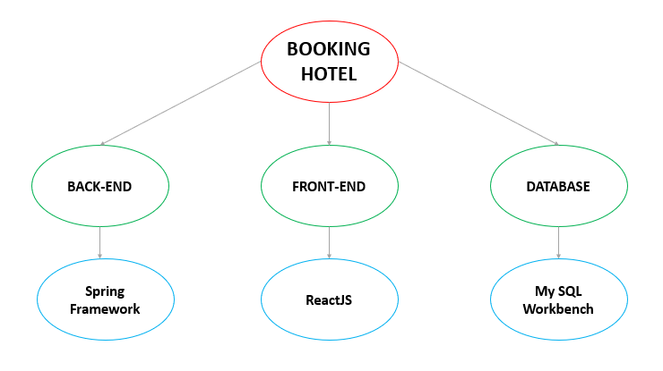

Figure 1: Over Architecture

* 1. **Conceptual data model ( CDM)**

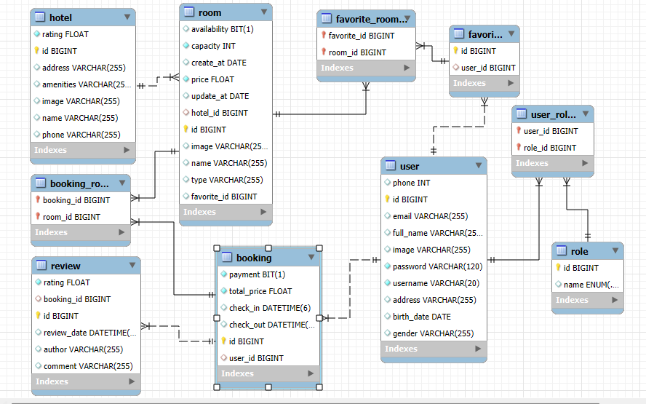

Figure 2 CDM

* 1. **Flowchart diagram of the system:**

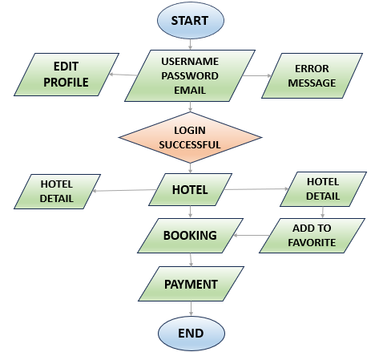

Figure 3 Flowchart

* 1. **System functions:**
     1. **Functions for customers**

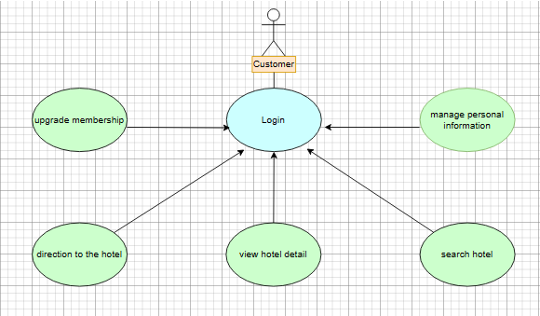

Figure 4: Customer function

Register and Login an account.

Manage personal information, upload avatar.

View details about the hotel

Search for hotels

Directions to the hotel

Rate the hotel after experiencing the stay

* + 1. **Functions for hotel owners**

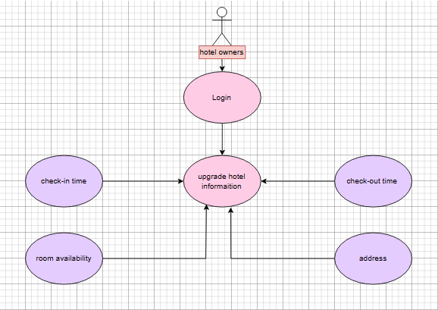

Figure 5: Hotel Owner function

Register and login an account

Update hotel information: check-in and check-out times, address, update room availability

* + 1. **Functions for administrators**

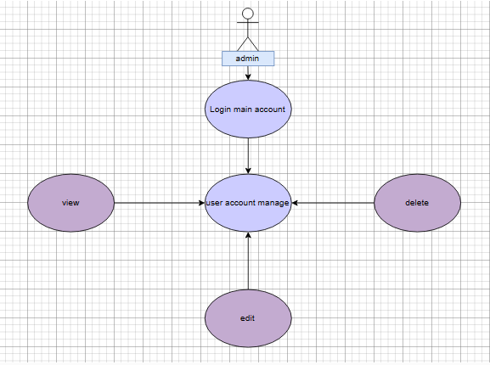

Figure 6: Admin funciton

Be given a separate account

Manage user accounts: view, edit, delete

* 1. **Database**
     1. **Hotels**

|  |  |  |  |
| --- | --- | --- | --- |
| **Properties** | **Datatypes** | **Primary Key** | **Not null** |
| Hotel_id | INT | X | X |
| Hotel_name | VARCHAR(255) |  | X |
| Address | VARCHAR(255) |  | X |
| Rating | FLOAT |  | X |
| Number_rooms | INT |  | X |
| Amenities | VARCHAR(255) |  | X |
| Hotel_image | VARCHAR(255) |  | X |

Table 1 Database hotels

* + 1. **Customers**

|  |  |  |  |
| --- | --- | --- | --- |
| **Properties** | **Datatypes** | **Primary Key** | **Not null** |
| Customer_id | INT | X | X |
| First_name | VARCHAR(255) |  | X |
| Last_name | VARCHAR(255) |  | X |
| Email | VARCHAR(255) |  | X |
| Phone | INT |  | X |
| Address | VARCHAR(255) |  | X |
| Customer_image | VARCHAR(255) |  | X |
| Account_id | INT |  | X |

Table 2 Database customers

* + 1. **Rooms**

|  |  |  |  |
| --- | --- | --- | --- |
| **Properties** | **Datatypes** | **Primary Key** | **Not null** |
| Room_id | INT | X | X |
| Hotel_id | INT |  | X |
| Room_type | VARCHAR(255) |  | X |
| Price_per_night | INT |  | X |
| Availability | BOOLEAN |  | X |
| Room_image | VARCHAR(255) |  | X |

Table 3 Database rooms

* + 1. **Reviews**

|  |  |  |  |
| --- | --- | --- | --- |
| **Properties** | **Datatypes** | **Primary Key** | **Not null** |
| Review_id | INT | X | X |
| Customer_id | INT |  | X |
| Rating | FLOAT |  | X |
| Comment | VARCHAR(255) |  | X |
| Date | DATE |  | X |

Table 4 Database reviews

* + 1. **Bookings**

|  |  |  |  |
| --- | --- | --- | --- |
| **Properties** | **Datatypes** | **Primary Key** | **Not null** |
| Booking_id | INT | X | X |
| Customer_id | INT |  | X |
| Room_id | INT |  | X |
| Check-in-date | DATE |  | X |
| Check-out-date | DATE |  | X |
| Total_price | INT |  | X |
| Pay | BOOLEAN |  | X |

Table 5 Database bookings

* + 1. **Accounts**

|  |  |  |  |
| --- | --- | --- | --- |
| **Properties** | **Datatypes** | **Primary Key** | **Not null** |
| Account_id | INT | X | X |
| Role | ENUM |  | X |
| Username | VARCHAR(255) |  | X |
| Password | VARCHAR(255) |  | X |
| Rank_account | ENUM |  | X |

Table 6 Database accounts

1. **SOLUTION IMPLEMENTATION**
   1. **Interface** 
      1. **Home**

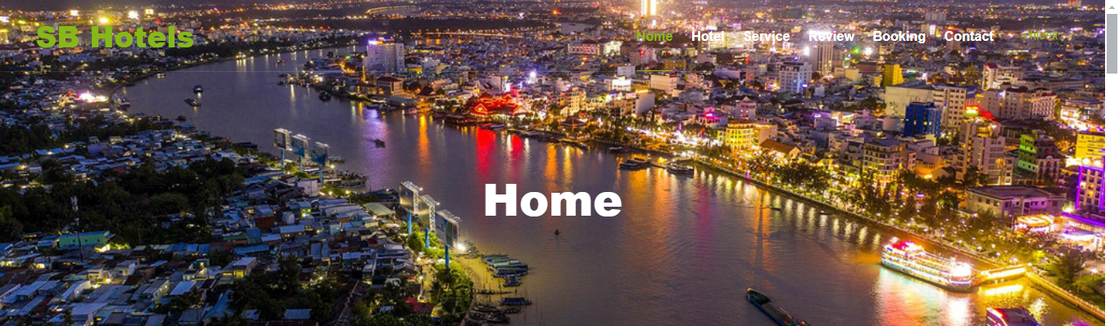

Figure 7: view Home / header

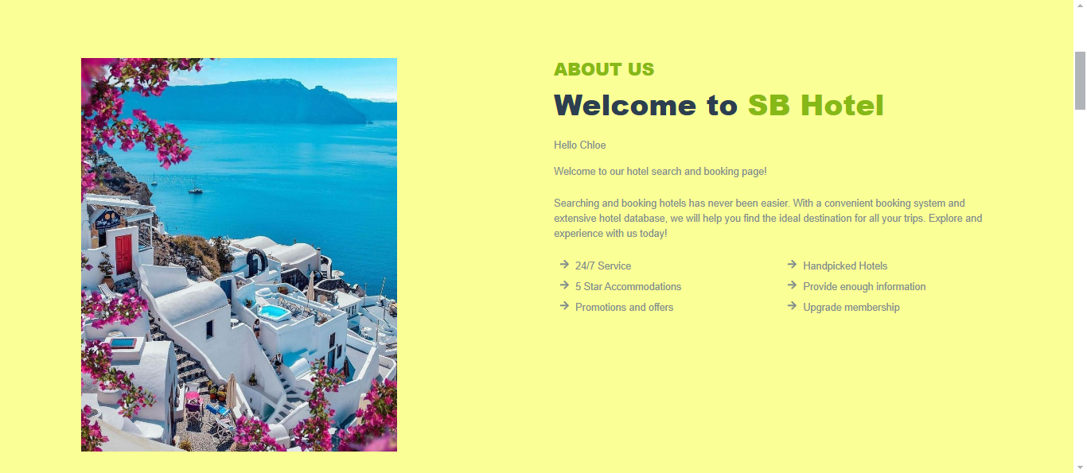

Figure 8: view Home / Welcome

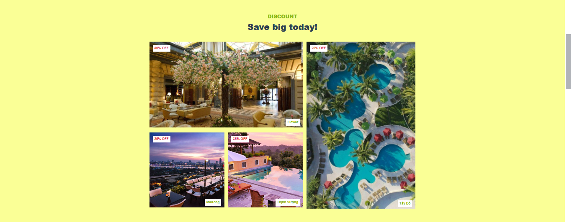

Figure 9: view Home / Discount

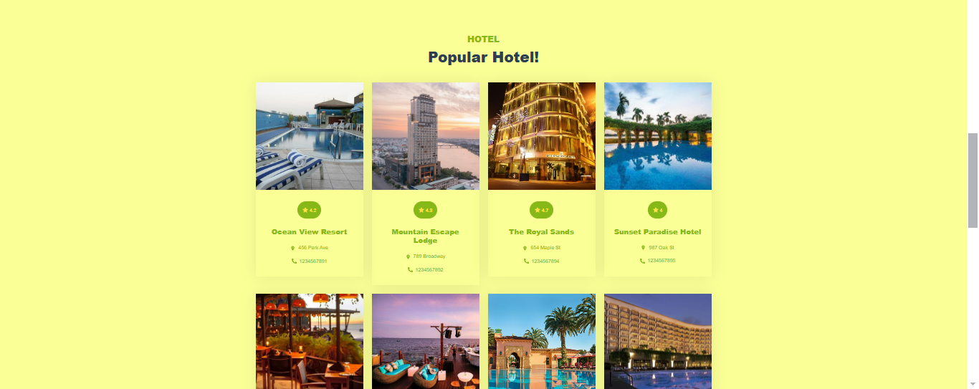

Figure 10: view Home / Popular Hotel

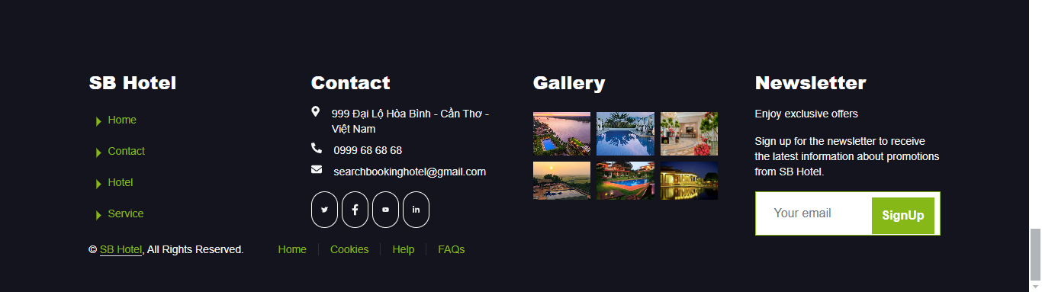

Figure 11: view Home / Footer

* + 1. **Hotel**

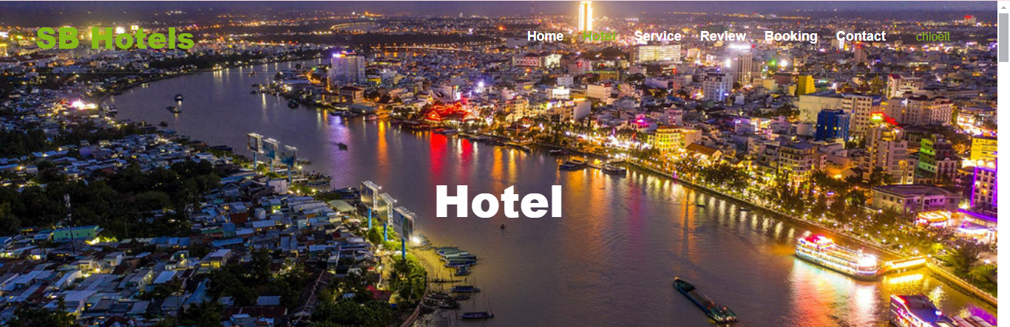

Figure 12: view Hotel

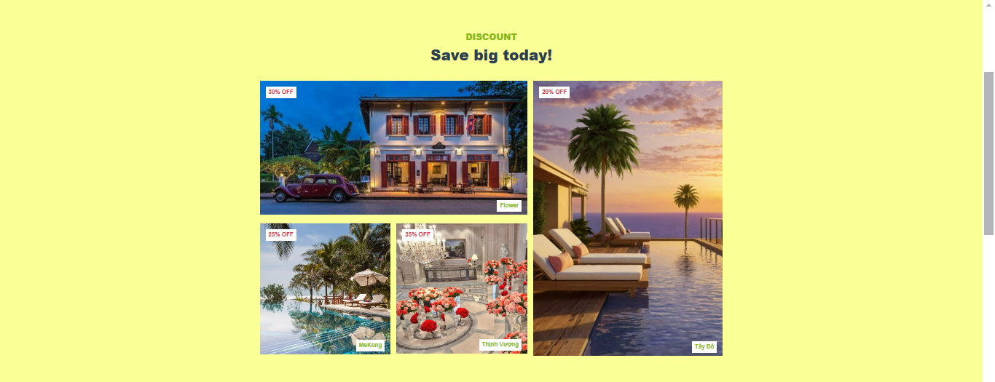

Figure 13: view Hotel / Discount

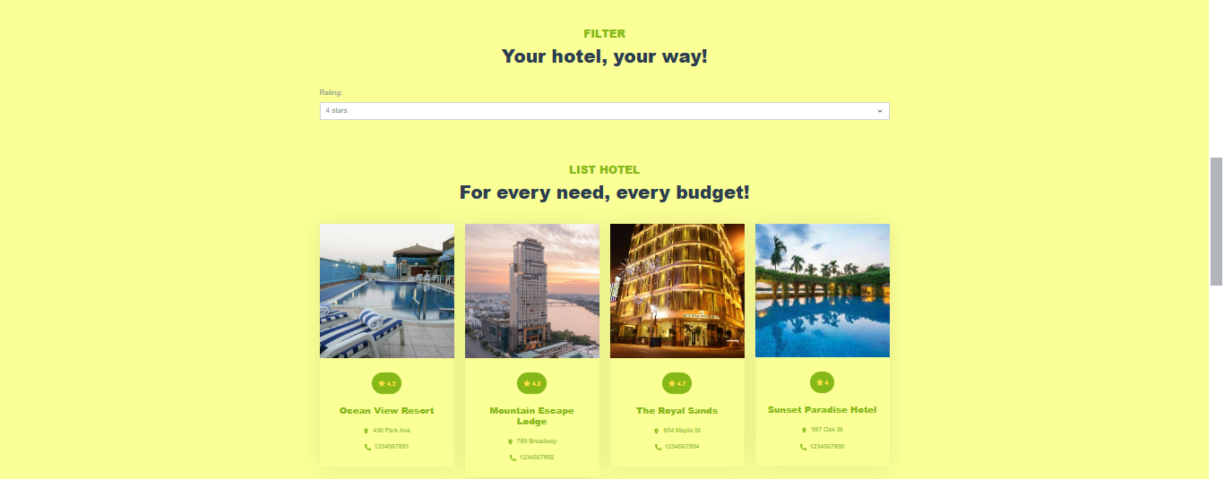

Figure 14: view Hotel / Filter & List Hotel

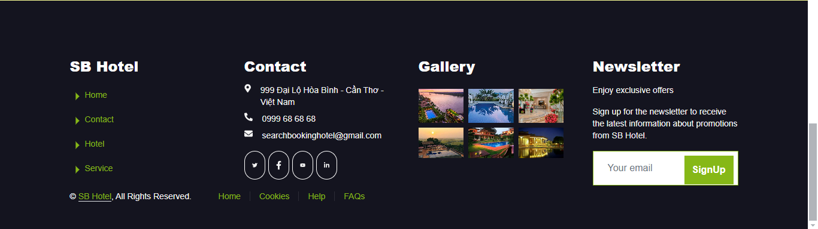

Figure 15: view Hotel / Footer

* + 1. **Service**

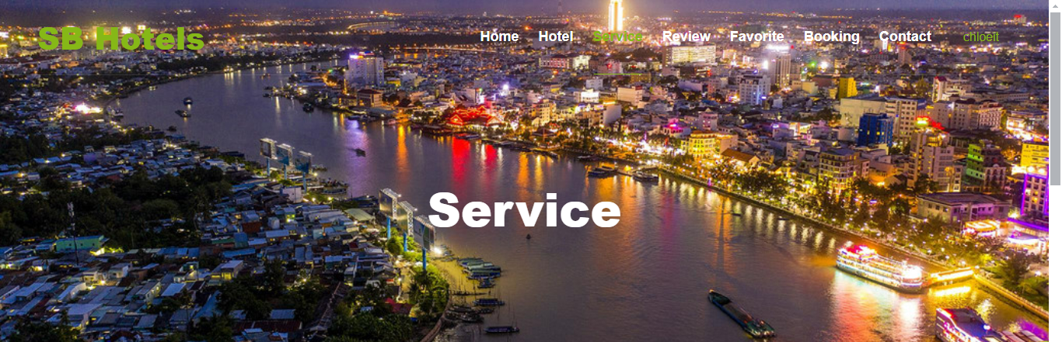

Figure 16: view Service / Header

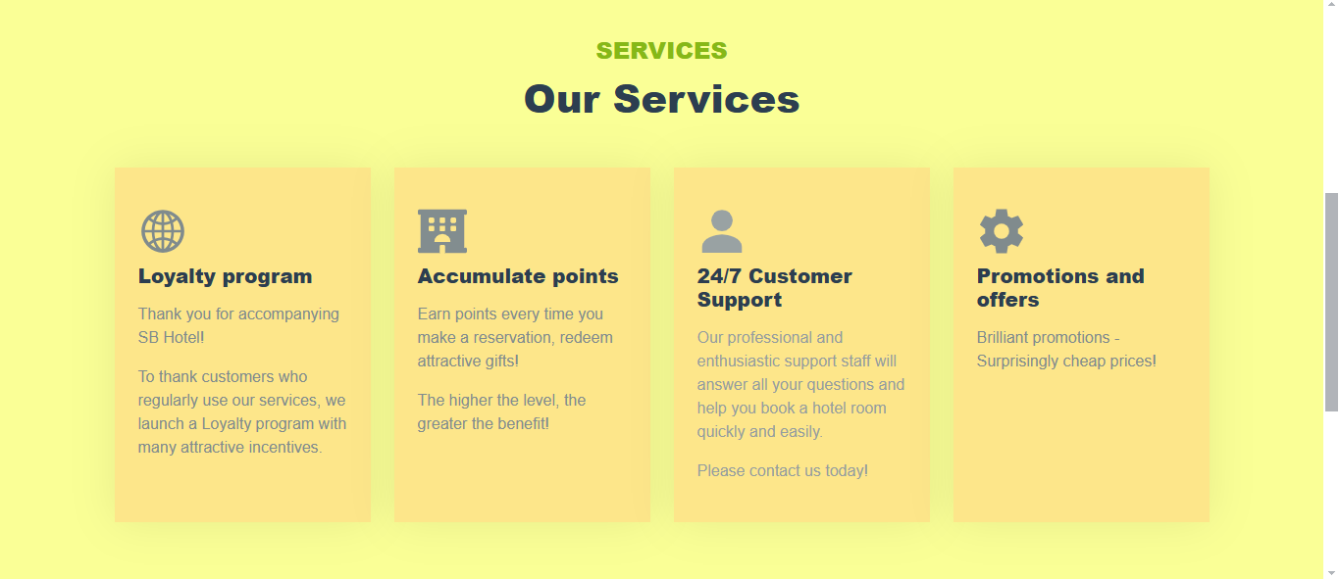

Figure 17: view Service

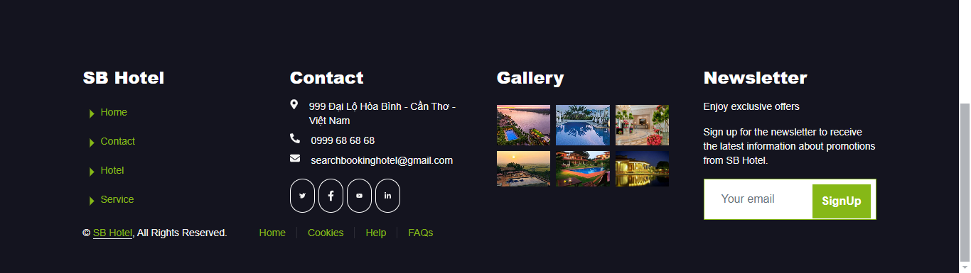

Figure 18: view Service / Footer

* + 1. **Review**

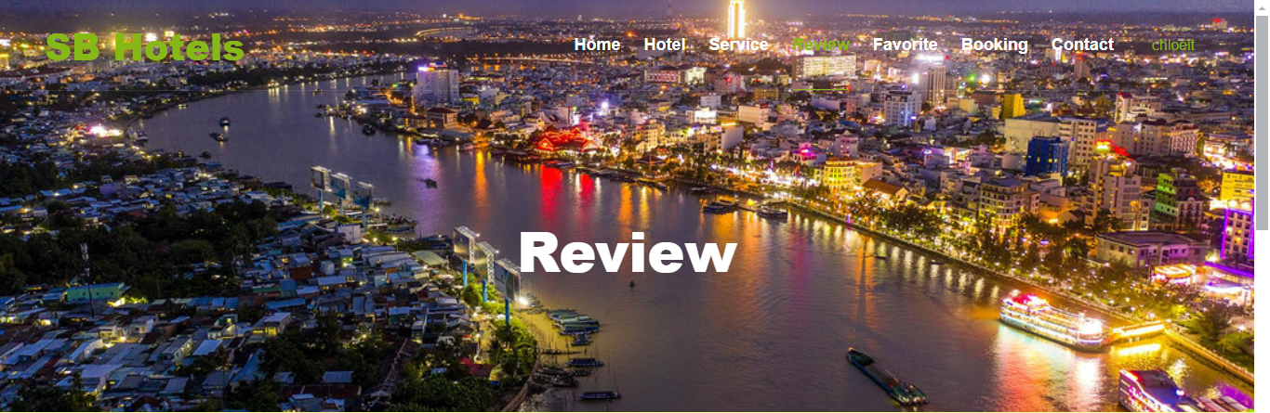

Figure 19: view Review / Header

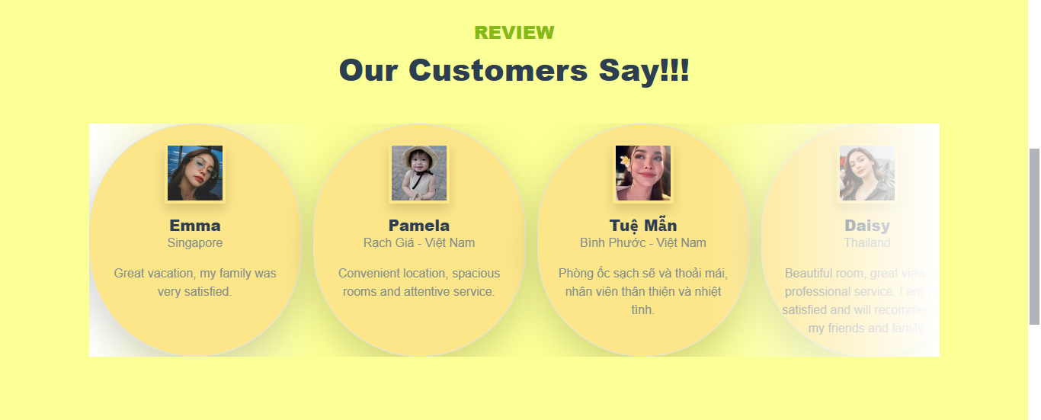

Figure 20: view Review

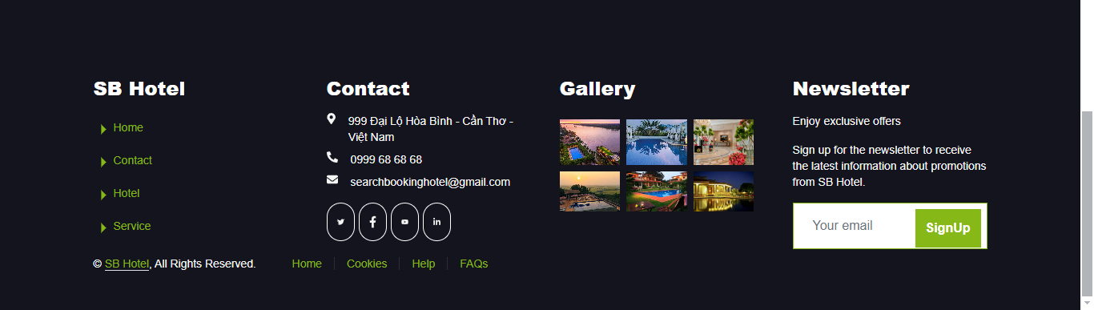

Figure 21: view Review / Footer

* + 1. **Contact**

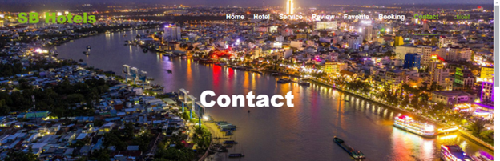

Figure 22: view Contact / Header

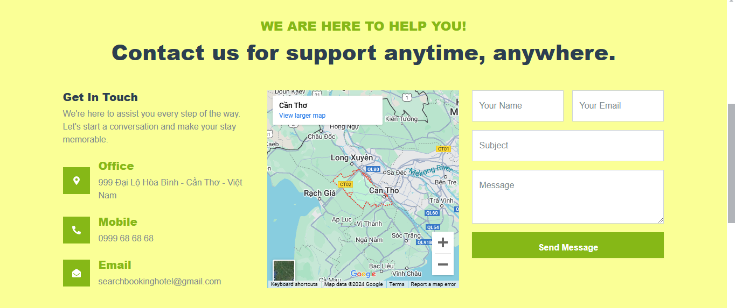

Figure 23: view Contact

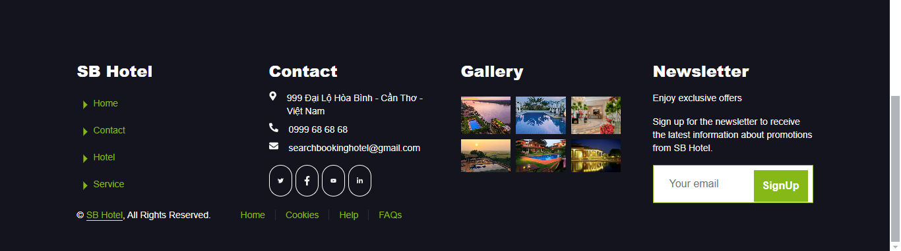

Figure 24: view Contact / Footer

* + 1. **Booking**

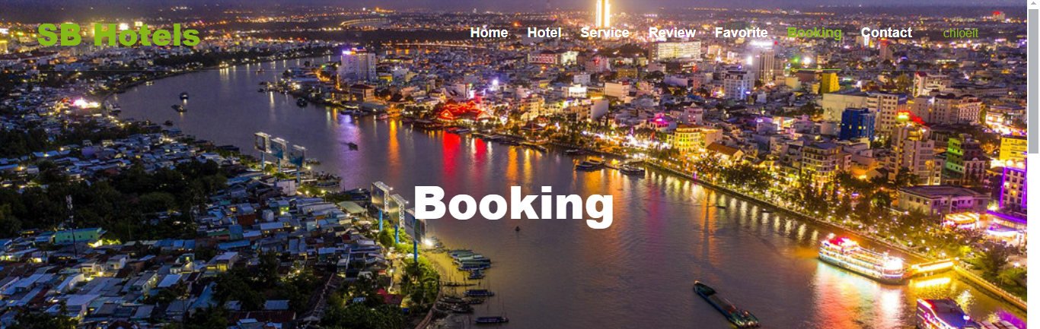

Figure 25: view Booking / Header

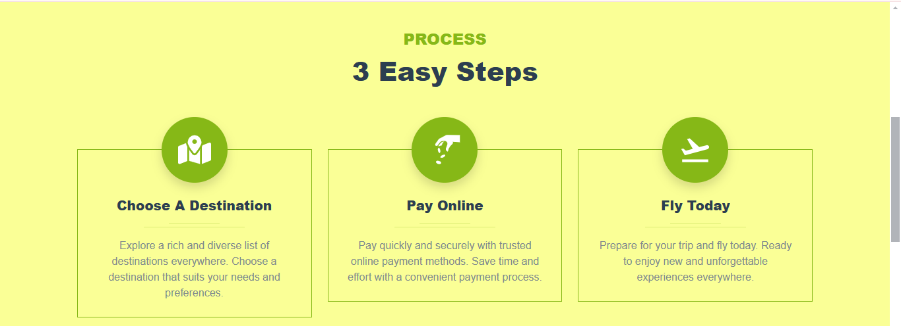

Figure 26: view Booking

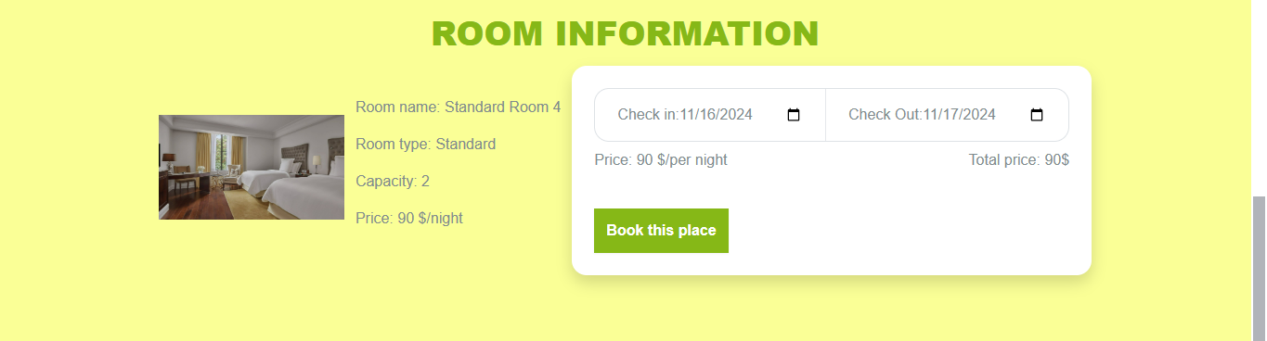

Figure 27: view Booking

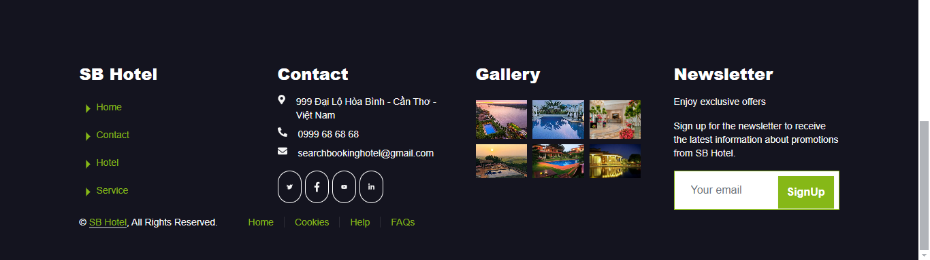

Figure 28: view Booking / Footer

* + 1. **Favorite**

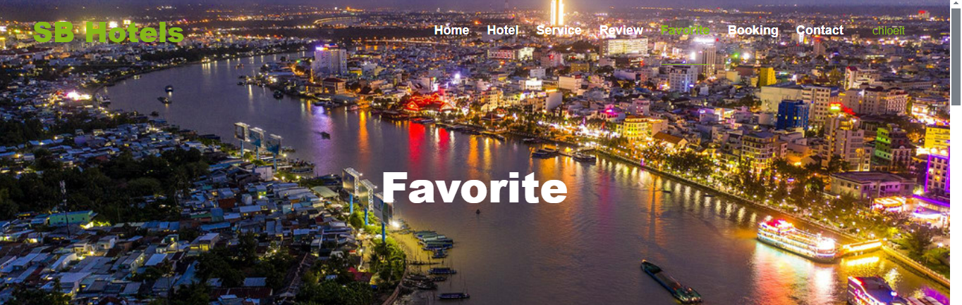

Figure 29: view Favorite / Header

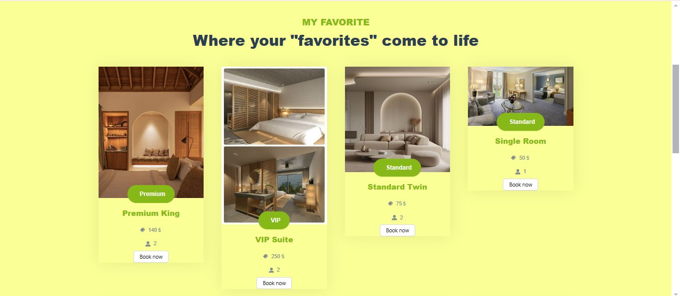

Figure 30: view Favorite

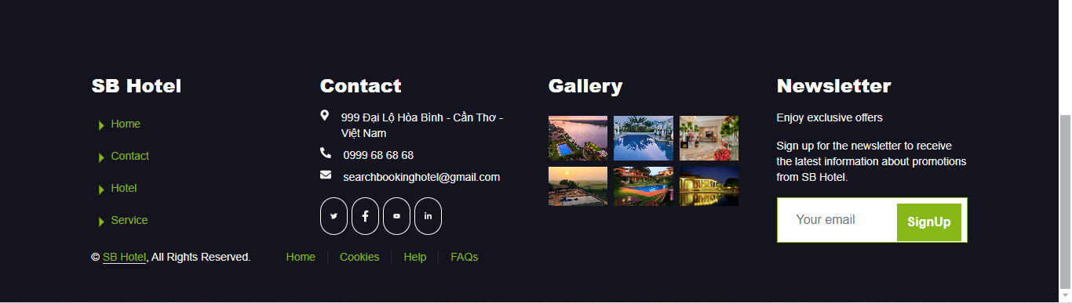

Figure 31: view Favorite / Footer

* + 1. **Profile**

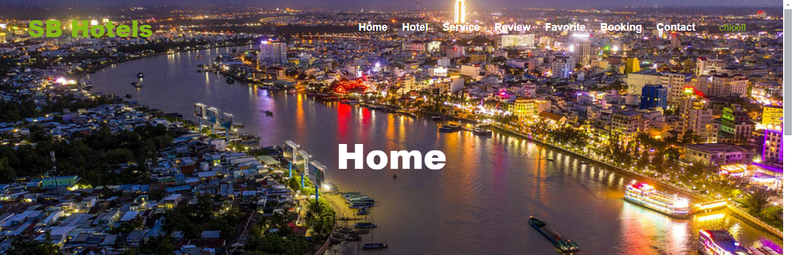

Figure 32: view Profile / Header

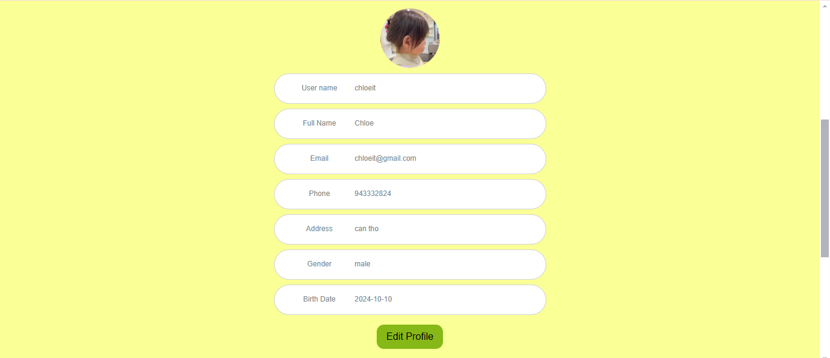

Figure 33: view Profile

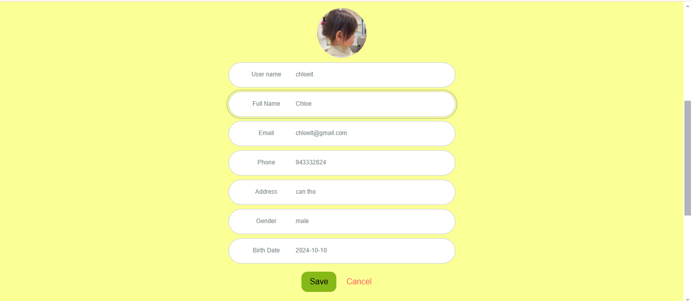

Figure 34:view Profile / edit Profile

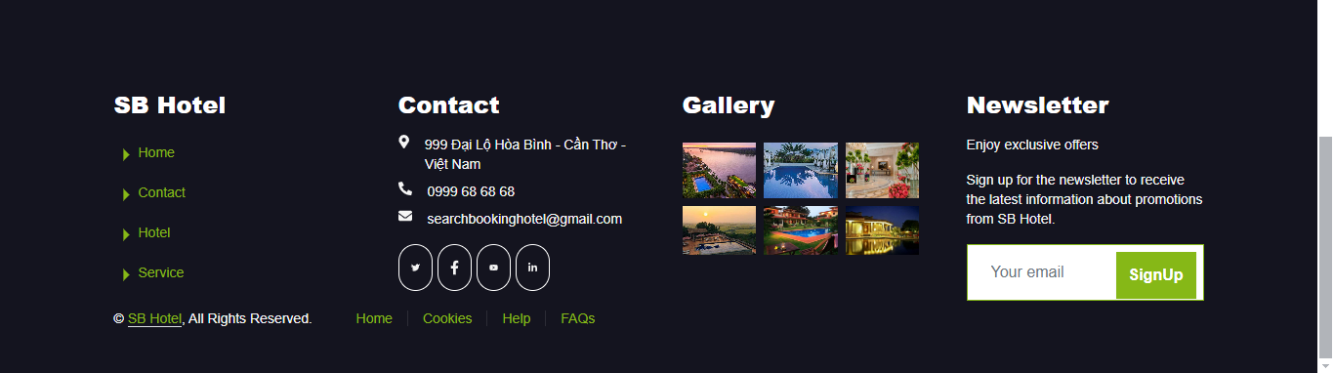

Figure 35: view Profile / Footer

* + 1. **Log-in**

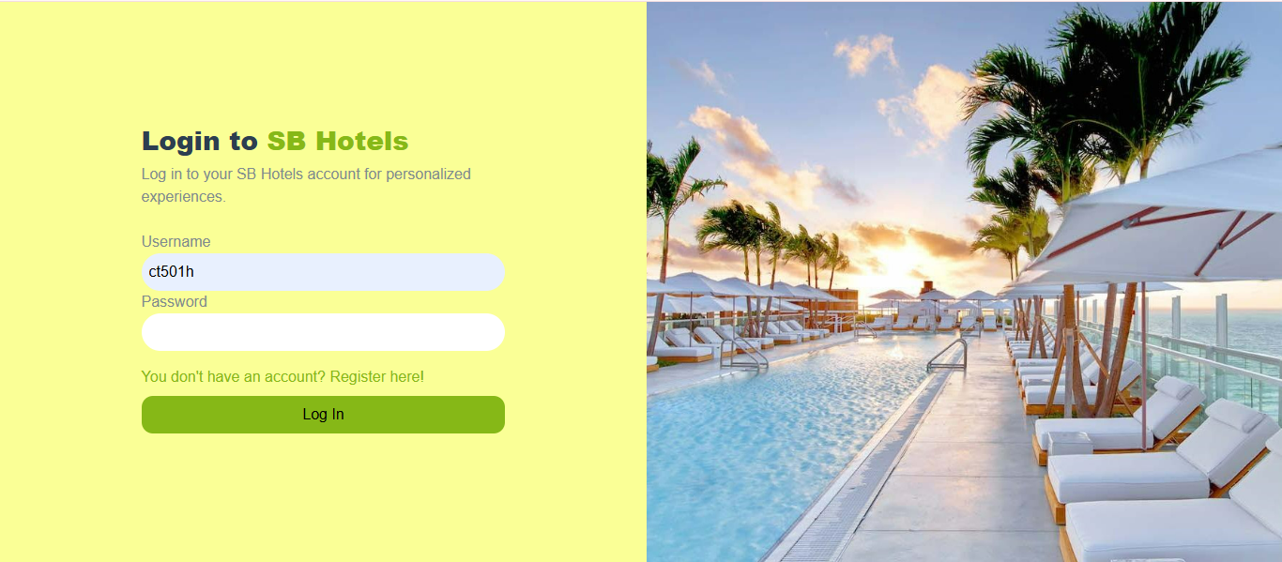

Figure 36: view LogIn

* + 1. **Register**

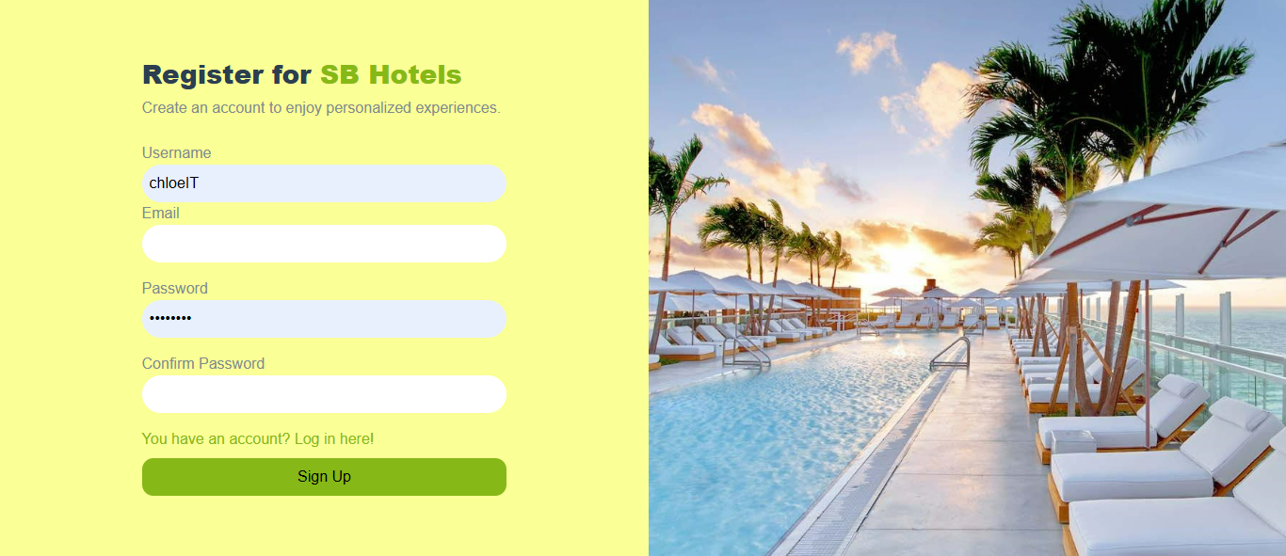

Figure 37: view Register

* + 1. **Admin Hotel**

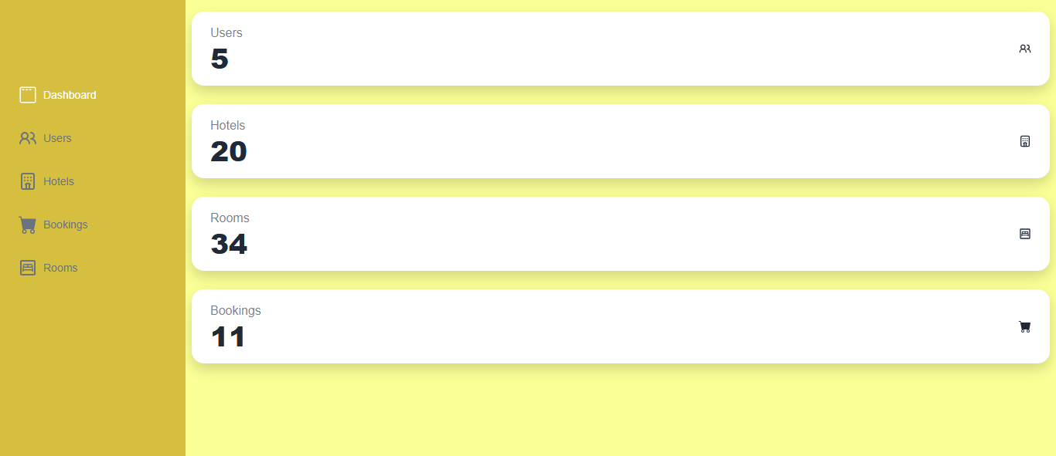

Figure 38: view Admin DashBoard

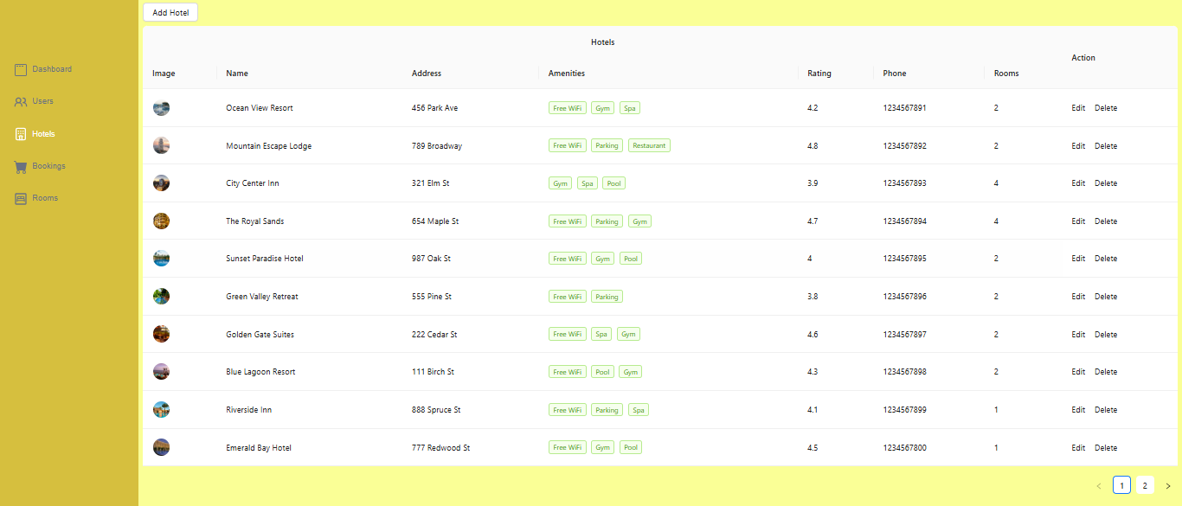

Figure 39: view Admin Hotel

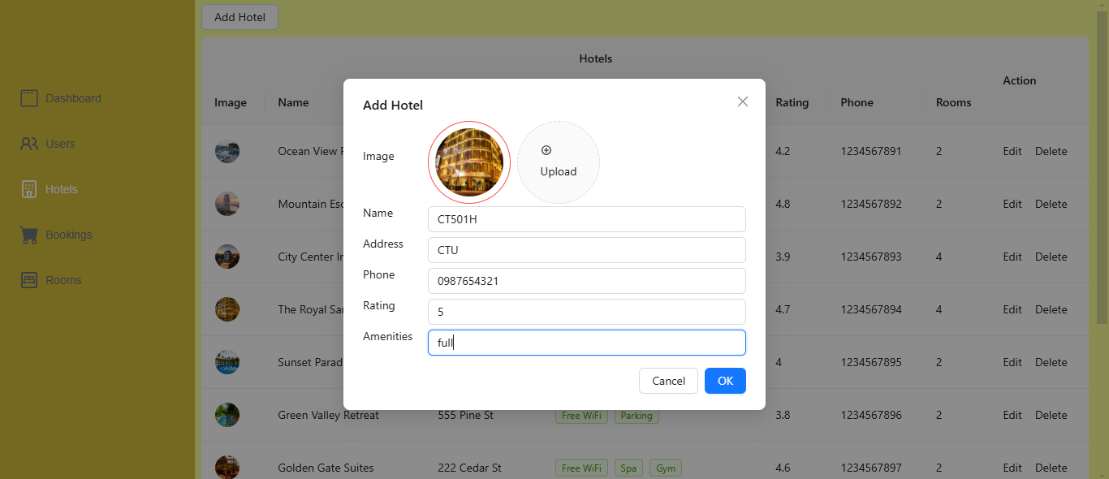

Figure 40: view Admin Hotel / add Hotel

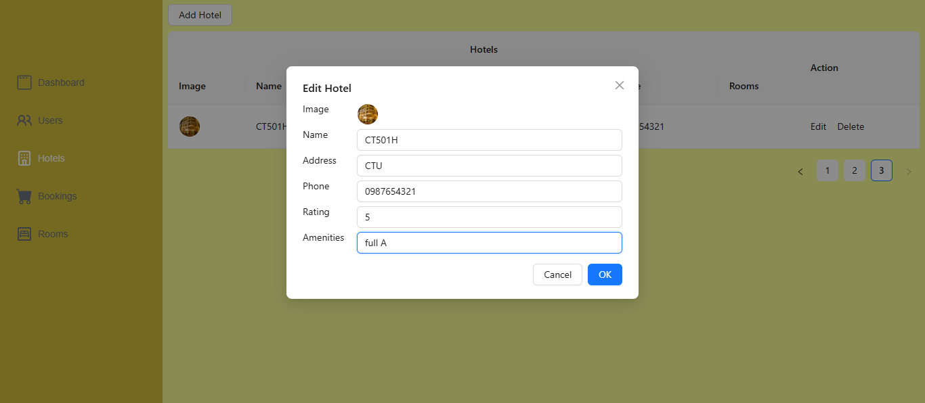

Figure 41: view Admin Hotel / edit Hotel

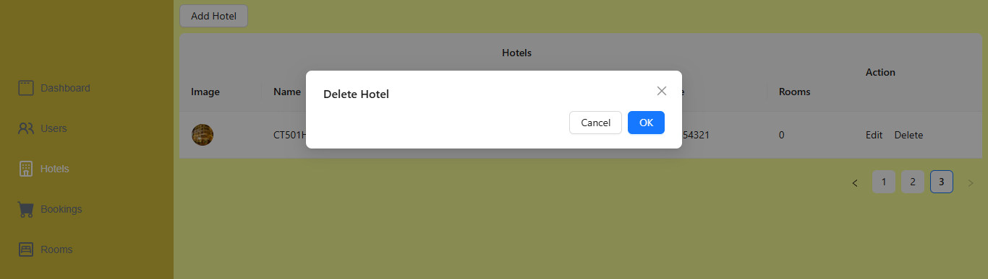

Figure 42: view Admin Hotel / delete Hotel

* + 1. **Admin Room**

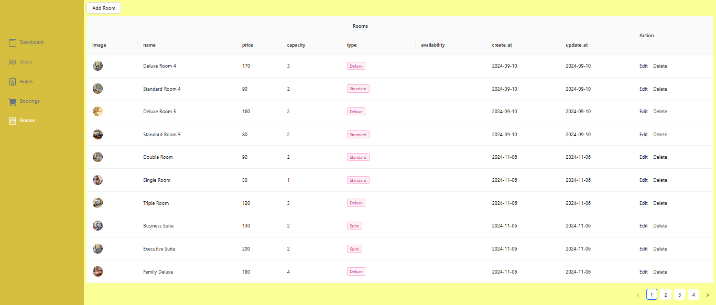

Figure 43: view Admin Room

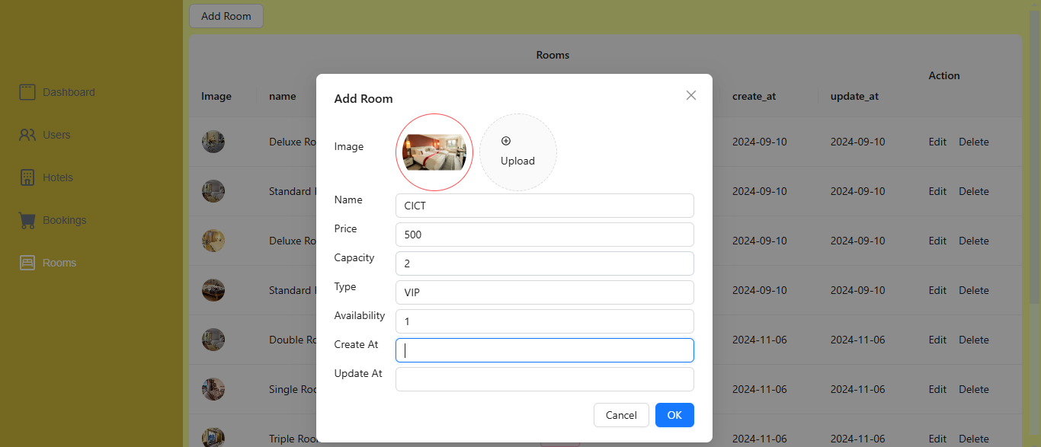

Figure 44: view Admin Room / add Room

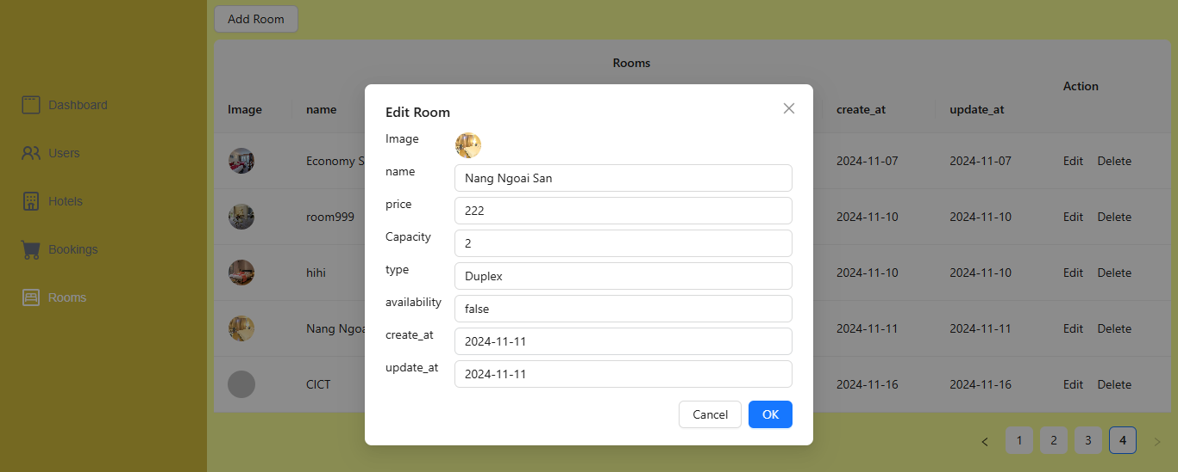

Figure 45: view Admin Room / edit Room

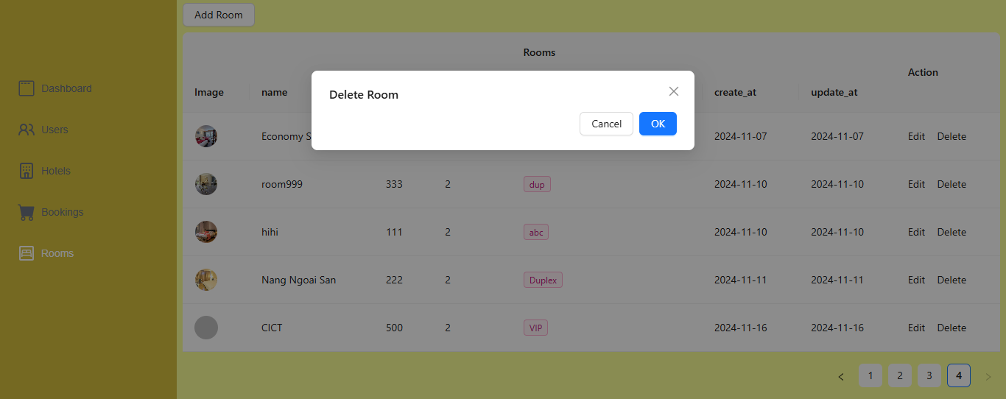

Figure 46: view Admin Room / delete Room

* + 1. **Admin Booking**

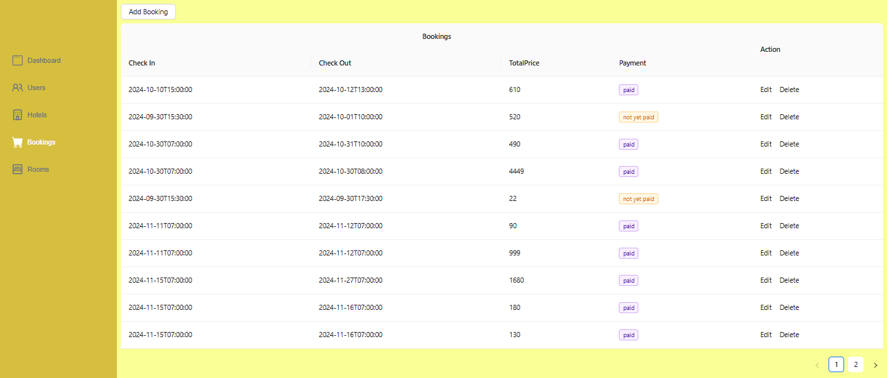

Figure 47: view Admin Booking

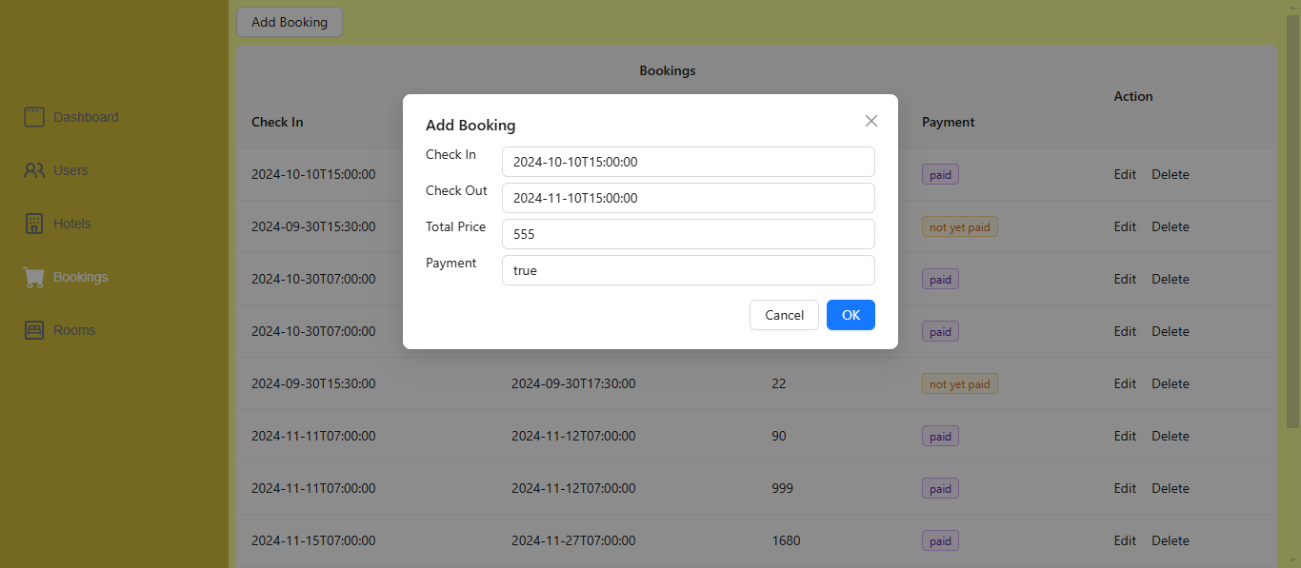

Figure 48: view Admin Booking / add Booking

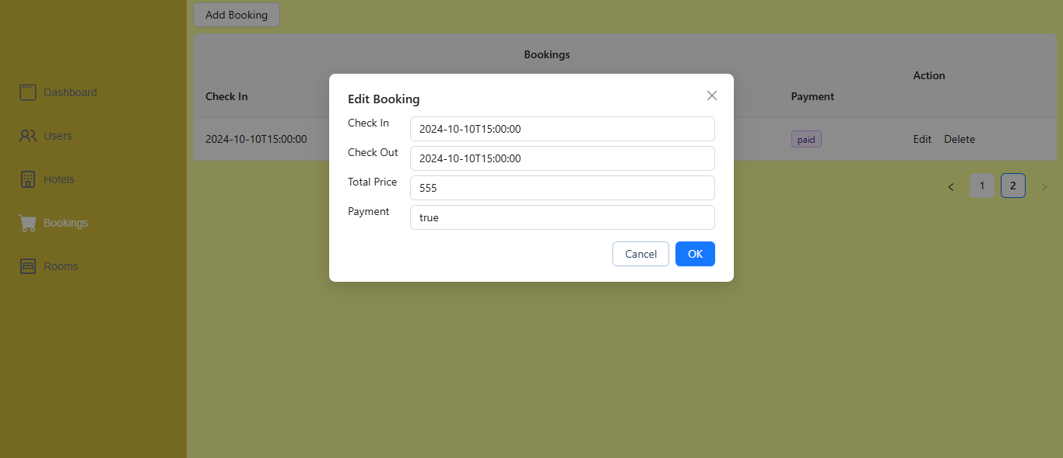

Figure 49: view Admin Booking / edit Booking

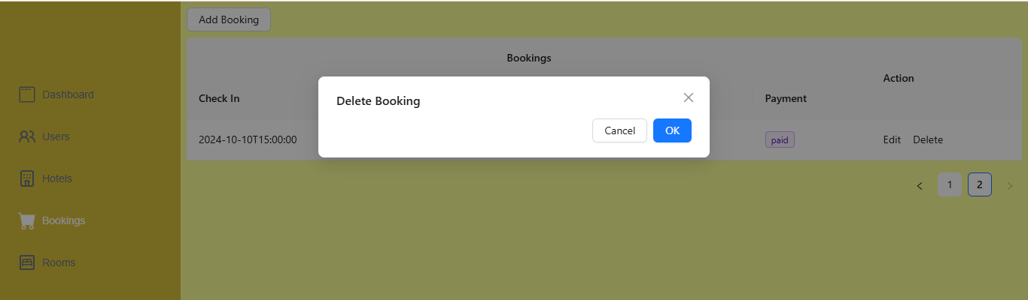

Figure 50: view Admin Booking / delete Booking

* + 1. **Admin User**

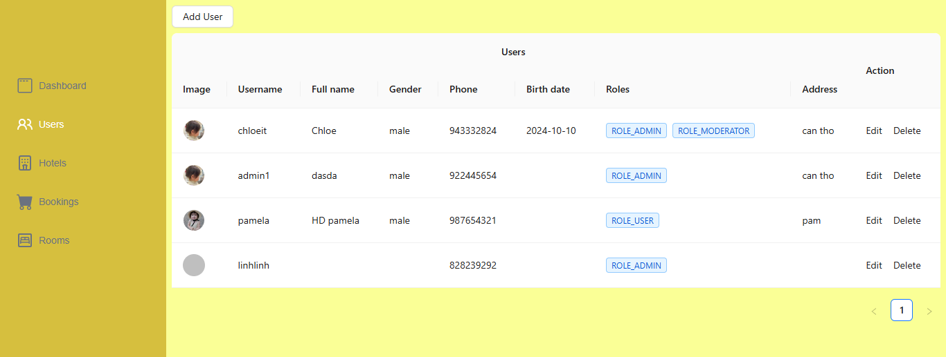

Figure 51: view Admin User

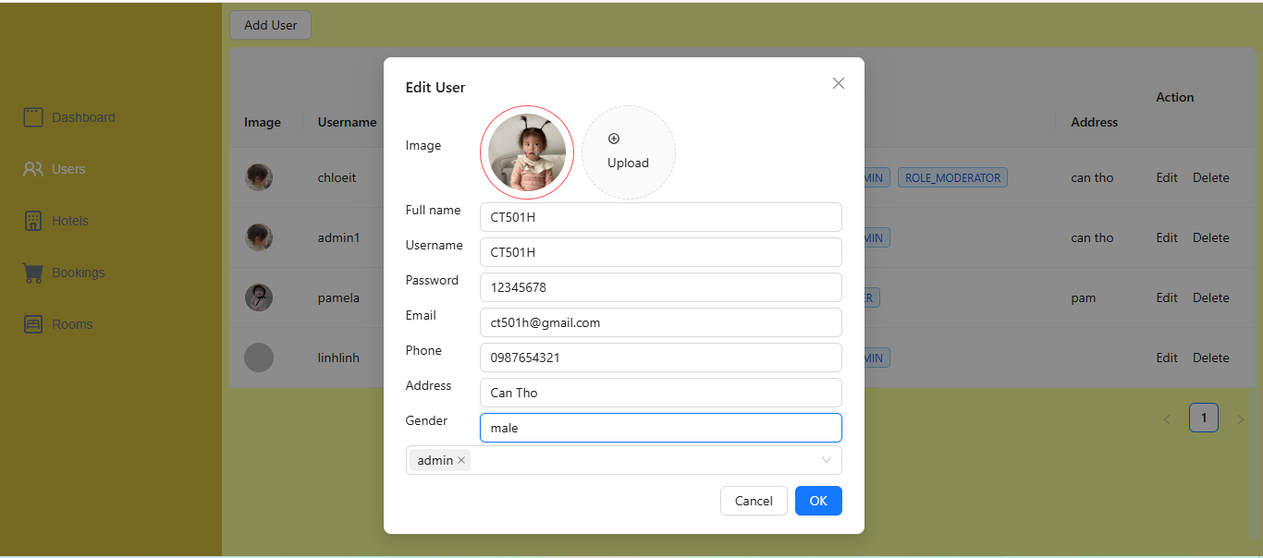

Figure 52: view Admin User / add User

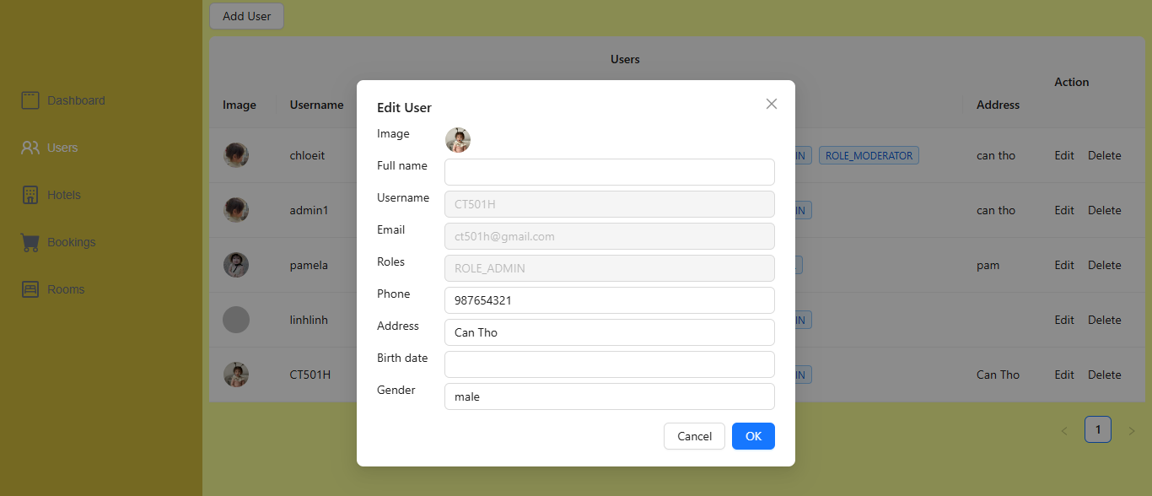

Figure 53: view Admin User / edit User

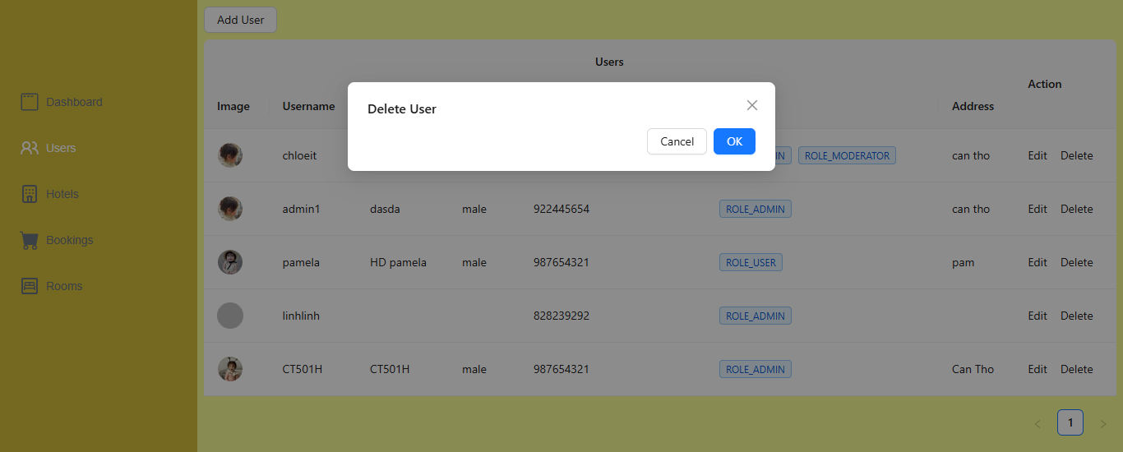

Figure 54: view Admin User / delete User

* 1. **Design Description using operating system and hardware**
     1. **Operating environment**
* Database system: MySQL
* Window 10, 11 operating system
* RAM: 8GB
* SSD: 512GB
* CPU: Intel Core i7
* Screen 14 inches or more
* Supports Internet connection
  + 1. **Requires external communication**
* Hardware communication:
* Interacts via mouse and keyboard
* Other supported devices: Wifi Modern
* Software communication:
* Use MySQL database management system
* Windows operating systems

1. **TESTING AND EVALUATION**
   1. **Testing objectives:**

* The main goal of testing is to detect errors and check whether the program meets the established requirements or not.
* The testing process includes usability testing, functional testing, compatibility testing, database testing, and security testing.
* Usability testing is checking whether the website and application are user friendly or not? Can new users understand the application easily or not.
* Links to the home page are available on each page.
* A confirmation message is displayed for any update operation.
* Check if the static path displayed on the browser is correct or not.
* Test all links to see if they work and if they go to the expected screen.
* Check the ability to force data entry, empty data, bind data, display a message when entering incorrect data.
* Check content: images, text on other devices.
* The content is accurate, without any spelling or grammatical errors
  1. **Testing scenarios:**
     1. **Register function**

|  |  |  |  |
| --- | --- | --- | --- |
| **Order** | **Test case description** | **Implementation steps** | **Implementation**  **date** |
| 1 | Customer register | 1. Open web 2. Register 3. Enter username & password 4. Click register | 17/09/2024 |

Table 7 Register funcion

* + 1. **Login function**

|  |  |  |  |
| --- | --- | --- | --- |
| **Order** | **Test case description** | **Implementation steps** | **Implementation**  **date** |
| 1 | Customer login | 1. Open web 2. Login 3. Enter username & password 4. Click login | 17/09/2024 |

Table 8: Login function

* + 1. **Update profile function**

|  |  |  |  |
| --- | --- | --- | --- |
| **Order** | **Test case description** | **Implementation steps** | **Implementation**  **date** |
| 1 | Customer update profile | 1. Open web 2. Login 3. Update profile 4. Click save changes | 17/10/2024 |

Table 9: Update profile function

* + 1. **Logout function**

|  |  |  |  |
| --- | --- | --- | --- |
| **Order** | **Test case description** | **Implementation steps** | **Implementation**  **date** |
| 1 | Customer logout | 1. Access website 2. Logout | 17/10/2024 |

Table 10: Logout function

* + 1. **Create Admin User function**

|  |  |  |  |
| --- | --- | --- | --- |
| **Order** | **Test case description** | **Implementation steps** | **Implementation**  **date** |
| 1 | Admin User | 1. Access admin rights 2. Start add, edit, delete user | 02/10/2024 |

Table 11 Create hotel function

* + 1. **Create Admin Booking function**

|  |  |  |  |
| --- | --- | --- | --- |
| **Order** | **Test case description** | **Implementation steps** | **Implementation**  **date** |
| 1 | Admin Booking | 1. Access admin rights 2. Start add, edit, delete booking | 02/10/2024 |

Table 12: Edit hotel function

* + 1. **Create Admin Hotel & Room function**

|  |  |  |  |
| --- | --- | --- | --- |
| **Order** | **Test case description** | **Implementation steps** | **Implementation**  **date** |
| 1 | Admin Hotel & Room | 1. Access admin rights 2. Start acess Admin Hotel & Room function | 30/10/2024 |

Table 13 : Delete hotel function

* + 1. **Create Add to Favorite function**

|  |  |  |  |
| --- | --- | --- | --- |
| **Order** | **Test case description** | **Implementation steps** | **Implementation**  **date** |
| 1 | Add to Favorite | 1. Access admin rights 2. Start acess Admin Hotel & Room function | 30/10/2024 |

Table 14 : Create Add to Favorite

* + 1. **Create Booking function**

|  |  |  |  |
| --- | --- | --- | --- |
| **Order** | **Test case description** | **Implementation steps** | **Implementation**  **date** |
| 1 | Booking | 1. Access admin rights 2. Start acess Admin Hotel & Room function | 30/10/2024 |

Table 15: Create Booking

* + 1. **Create Payment function**

|  |  |  |  |
| --- | --- | --- | --- |
| **Order** | **Test case description** | **Implementation steps** | **Implementation**  **date** |
| 1 | Payment | 1. Access admin rights 2. Start acess Admin Hotel & Room function | 30/10/2024 |

Table 16: Payment

* + 1. **Create Filter Hotel function**

|  |  |  |  |
| --- | --- | --- | --- |
| **Order** | **Test case description** | **Implementation steps** | **Implementation**  **date** |
| 1 | Payment | 1. Access admin rights 2. Start acess Admin Hotel & Room function | 30/10/2024 |

Table 17: Filter

* 1. **Testing results:**
     1. **Register function**

|  |  |  |  |  |
| --- | --- | --- | --- | --- |
| **order** | **Test case description** | **Implementation steps** | **Implementation**  **date** | **Result** |
| 1 | Customer register | 1. Open web 2. Register 3. Enter username & password 4. Click register | 17/03/2024 | success |

Table 18: Testing register function

* + 1. **Login function**

|  |  |  |  |  |
| --- | --- | --- | --- | --- |
| **order** | **Test case description** | **Implementation steps** | **Implementation**  **date** | **Result** |
| 1 | Customer login | 1. Open web 2. Login 3. Enter username & password 4. Click login | 30/03/2024 | success |

Table 19: Testing login function

* + 1. **Update profile function**

|  |  |  |  |  |
| --- | --- | --- | --- | --- |
| **order** | **Test case description** | **Implementation steps** | **Implementation date** | **Result** |
| 1 | Customer update profile | 1. Open web 2. Login 3. Update profile 4. Click save changes | 10/04/2024 | success |

Table 20: Testing update profile function

* + 1. **Logout function**

|  |  |  |  |  |
| --- | --- | --- | --- | --- |
| **order** | **Test case description** | **Implementation steps** | **Implementation**  **date** | **Result** |
| 1 | Customer logout | 1. Access web 2. Logout | 30/04/2024 | success |

Table 21: Testing logout function

* + 1. **Admin User function**

|  |  |  |  |  |
| --- | --- | --- | --- | --- |
| **order** | **Test case description** | **Implementation steps** | **Implementation**  **date** | **Result** |
| 1 | Create hotel | 1. Access admin rights 2. Start creating a new hotel | 02/05/2024 | success |

Table 22: Testing create hotel function

* + 1. **Admin Booking function**

|  |  |  |  |  |
| --- | --- | --- | --- | --- |
| **order** | **Test case description** | **Implementation steps** | **Implementation**  **date** | **Result** |
| 1 | Create hotel | 1. Access admin rights 2. Start edit hotel | 02/05/2024 | success |

Table 23: Testing edit hotel function

* + 1. **Admin Hotel & Room function**

|  |  |  |  |  |
| --- | --- | --- | --- | --- |
| **order** | **Test case description** | **Implementation steps** | **Implementation**  **date** | **Result** |
| 1 | Create hotel | 1. Access admin rights 2. Start delete hotel | 02/05/2024 | success |

Table 24: Testing delete hotel function

* + 1. **Add to Favorite function**

|  |  |  |  |  |
| --- | --- | --- | --- | --- |
| **order** | **Test case description** | **Implementation steps** | **Implementation**  **date** | **Result** |
| 1 | Create hotel | 1. Access admin rights 2. Start delete hotel | 02/05/2024 | success |

Table 25: Add to Favorite

* + 1. **Booking function**

|  |  |  |  |  |
| --- | --- | --- | --- | --- |
| **order** | **Test case description** | **Implementation steps** | **Implementation**  **date** | **Result** |
| 1 | Create hotel | 1. Access admin rights 2. Start delete hotel | 02/05/2024 | success |

Table 26: Booking

* + 1. **Payment function**

|  |  |  |  |  |
| --- | --- | --- | --- | --- |
| **order** | **Test case description** | **Implementation steps** | **Implementation**  **date** | **Result** |
| 1 | Create hotel | 1. Access admin rights 2. Start delete hotel | 02/05/2024 | success |

Table 27: Payment

* + 1. **Filter Hotel function**

|  |  |  |  |  |
| --- | --- | --- | --- | --- |
| **order** | **Test case description** | **Implementation steps** | **Implementation**  **date** | **Result** |
| 1 | Create hotel | 1. Access admin rights 2. Start delete hotel | 02/05/2024 | success |

Table 28: Filter Hotel

1. CONCLUSION
2. **Achieved results :**

* Basically, "Hotel search and booking website" has achieved its set goals.
* Build a customer-friendly interface with features: allowing customers to register, log in to their account, and view hotel information.

1. **Future directions:**

* For the system to work better, there needs to be a future orientation develop. The goal is set to improve and develop the system.
* Build more diverse data sources, closer to reality
* Build and develop more functions for administrators, hotels and customers
* Add advanced functions such as: Chatbox, reviews...
* Improved interface, increased user experience

# TÀI LIỆU THAM KHẢO

**abc**

# PHỤ LỤC

abc